# Tutorial 1-2023/09/06

1. Write a html code for the table.

|  |  |  |
| --- | --- | --- |
|  |  |  |
|  |  |  |
|  |  |  |

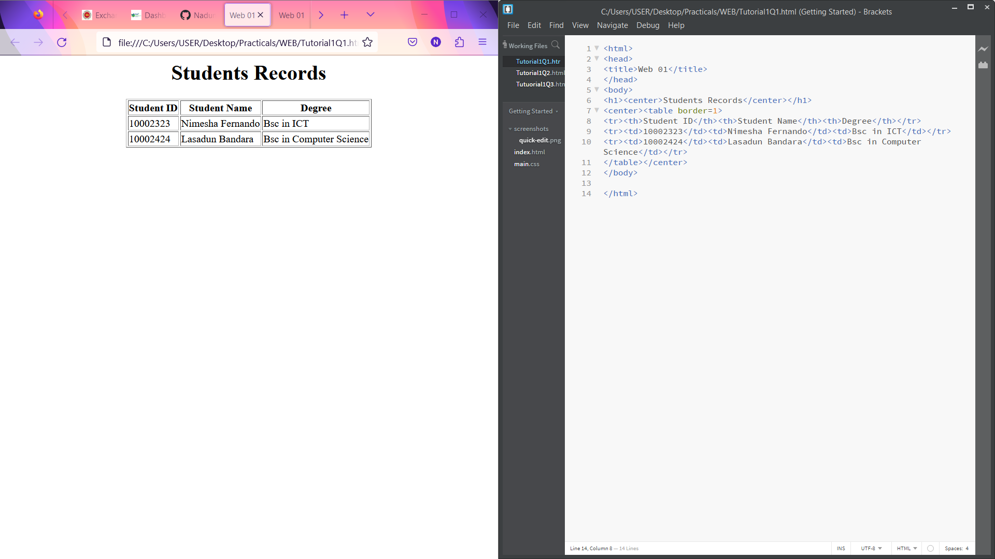

2.Write a html code to get the output

Programming languages

I.C

II.C#

III.C++

IV.JAVAV

V.PYTHON

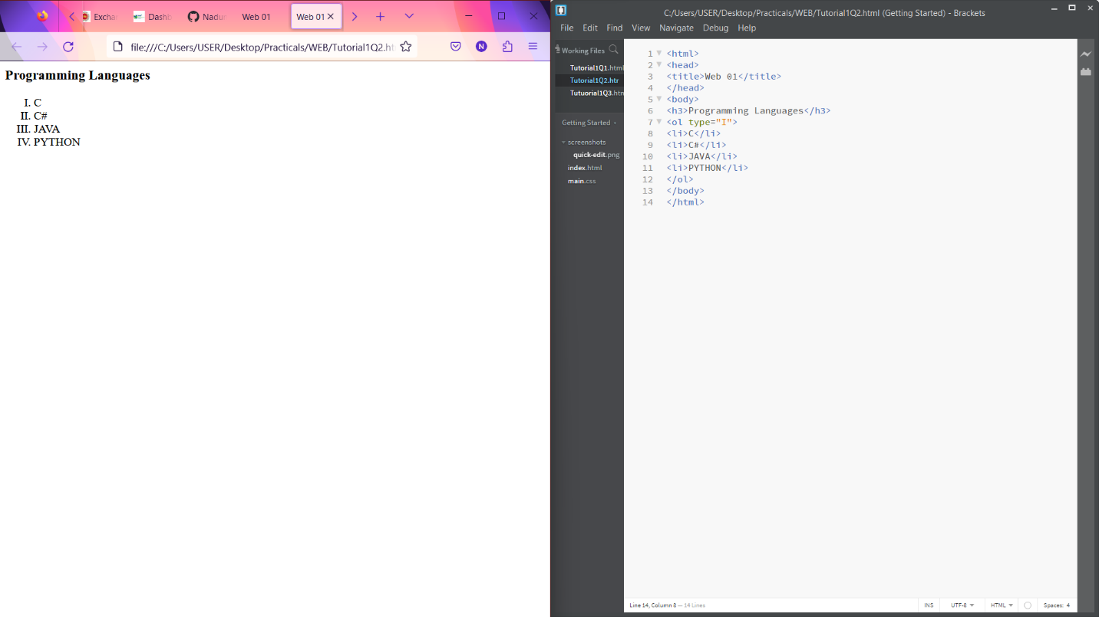

3.Create a form using Html tags.

